ASSIGNMENT-1

DOMAIN:IOT

TITLE:SMART HOME

Team Leader :

1) INIYAVAN V (611219106030)

Team members:

1. NIVAS S (611219106053)
2. DURAISHANMUGAM G (611219106020)
3. KALAIVANAN M (61129106034)

SMART Home Circuit Connection:

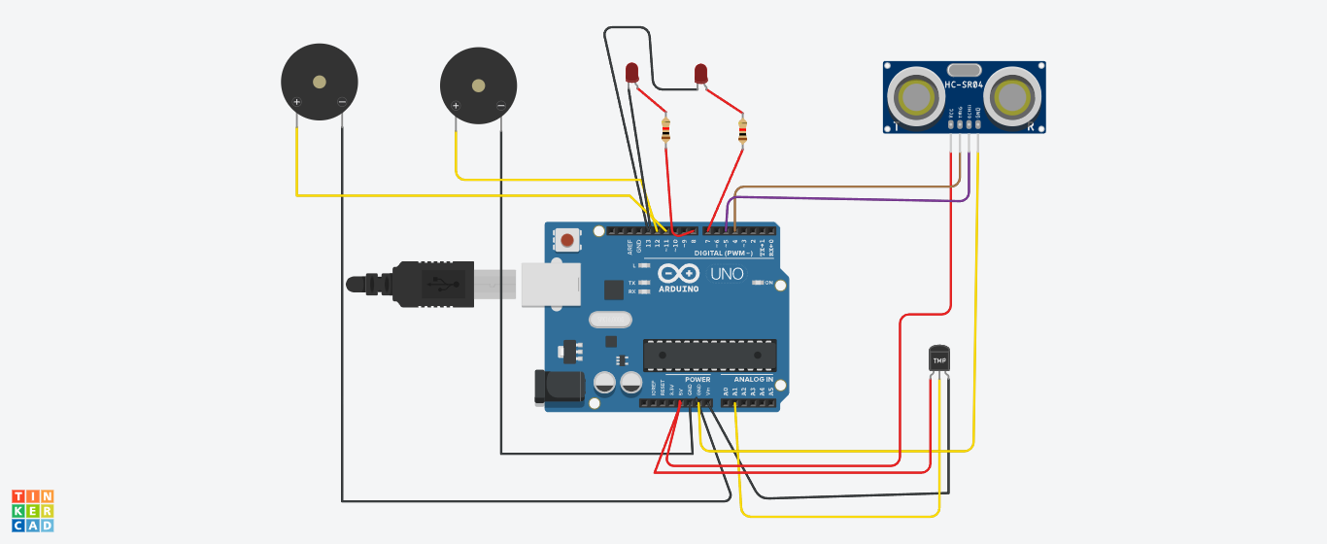

Components Used:

i) 2 Piezo Buzzers

ii) Temperature Sensor

iii)Ultrasonic Sensor

iv) LED -2

V) Resistor-2

CODE:

int t=2;

int e=3;

void setup()

{

Serial.begin(9600);

pinMode(t,OUTPUT);

pinMode(e,INPUT);

pinMode(12,OUTPUT);

}

void loop()

{

//ultrasonic sensor

digitalWrite(t,LOW);

digitalWrite(t,HIGH);

delayMicroseconds(10);

digitalWrite(t,LOW);

float dur=pulseIn(e,HIGH);

float dis=(dur*0.0343)/2;

Serial.print("Distance is: ");

Serial.println(dis);

//LED ON

if(dis>=100)//(in terms of centimeter)

{

digitalWrite(8,HIGH);

digitalWrite(7,HIGH);

}

//Buzzer For ultrasonic Sensor

if(dis>=100)

{

for(int i=0; i<=30000; i=i+10)

{

tone(12,i);

delay(1000);

noTone(12);

delay(1000);

}

}

//Temperate Sensor

double a= analogRead(A0);

double t=(((a/1024)*5)-0.5)*100;

Serial.print("Temp Value: ");

Serial.println(t);

delay(1000);

//LED ON

if(t>=100)//(in terms of celsius)

{

digitalWrite(8,HIGH);

digitalWrite(7,HIGH);

}

//Buzzer for Temperature Sensor

if(t>=100)

{

for(int i=0; i<=30000; i=i+10)

{

tone(12,i);

delay(1000);

noTone(12);

delay(1000);

}

}

//LED OFF

if(t<100)

{

digitalWrite(8,LOW);

digitalWrite(7,LOW);

}

}

TINKERCAD LINK:

<https://www.tinkercad.com/things/jbZI96Souwg-cool-krunk/editel?sharecode=iZOPRUsK8wYUcnAH0WVMm-xvOigE-mkMT6z2SYtwaOE>

Team Members-2: NIVAS S

Register Number: 611219106053

Schematic (Circuit Diagram)

SMART Home Circuit Connection:

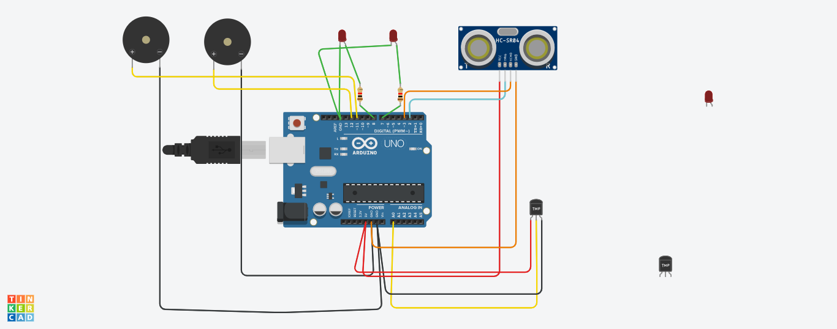

Components Used:

i) 2 Piezo Buzzer

ii)Temperature Sensor

iii)Ultrasonic Sensor

iv) LED -2

v)Resistor-2

**Code:**

int t=2;

int e=3;

void setup()

{

Serial.begin(9600);

pinMode(t,OUTPUT);

pinMode(e,INPUT);

pinMode(12,OUTPUT);

}

void loop()

{

//ultrasonic sensor

digitalWrite(t,LOW);

digitalWrite(t,HIGH);

delayMicroseconds(10);

digitalWrite(t,LOW);

float dur=pulseIn(e,HIGH);

float dis=(dur*0.0343)/2;

Serial.print("Distance is: ");

Serial.println(dis);

//LED ON

if(dis>=100)//(in terms of centimeter)

{

digitalWrite(8,HIGH);

digitalWrite(7,HIGH);

}

//Buzzer For ultrasonic Sensor

if(dis>=100)

{

for(int i=0; i<=30000; i=i+10)

{

tone(12,i);

delay(1000);

noTone(12);

delay(1000);

}

}

//Temperate Sensor

double a= analogRead(A0);

double t=(((a/1024)*5)-0.5)*100;

Serial.print("Temp Value: ");

Serial.println(t);

delay(1000);

//LED ON

if(t>=100)//(in terms of celsius)

{

digitalWrite(8,HIGH);

digitalWrite(7,HIGH);

}

/Buzzer for Temperature Sensor

if(t>=100)

{

for(int i=0; i<=30000; i=i+10)

{

tone(12,i);

delay(1000);

noTone(12);

delay(1000);

}

}

//LED OFF

if(t<100)

{

digitalWrite(8,LOW);

digitalWrite(7,LOW);

}

}

**TINKERCAD LINK:**

<https://www.tinkercad.com/things/04FPijtpzQx-sizzling-wluff/editel?sharecode=crzWiaOKQ60gifycKs5plLr2No2f9OiiS32dXeYGf74>

Team Members-3: DURAISHANMUGAM G

Register Number: 611219106020

Schematic (Circuit Diagram)

SMART Home Circuit Connection:



Components Used:

i) 2 Piezo Buzzer

ii)Temperature Sensor

iii)Ultrasonic Sensor

iv) LED -2

v)Resistor-2

**Code:**

int t=2;

int e=3;

void setup()

{

Serial.begin(9600);

pinMode(t,OUTPUT);

pinMode(e,INPUT);

pinMode(12,OUTPUT);

}

void loop()

{

//ultrasonic sensor

digitalWrite(t,LOW);

digitalWrite(t,HIGH);

delayMicroseconds(10);

digitalWrite(t,LOW);

float dur=pulseIn(e,HIGH);

float dis=(dur*0.0343)/2;

Serial.print("Distance is: ");

Serial.println(dis);

//LED ON

if(dis>=100)//(in terms of centimeter)

{

digitalWrite(8,HIGH);

digitalWrite(7,HIGH);

}

//Buzzer For ultrasonic Sensor

if(dis>=100)

{

for(int i=0; i<=30000; i=i+10)

{

tone(12,i);

delay(1000);

noTone(12);

delay(1000);

}

}

//Temperate Sensor

double a= analogRead(A0);

double t=(((a/1024)*5)-0.5)*100;

Serial.print("Temp Value: ");

Serial.println(t);

delay(1000);

//LED ON

if(t>=100)//(in terms of celsius)

{

digitalWrite(8,HIGH);

digitalWrite(7,HIGH);

}

/Buzzer for Temperature Sensor

if(t>=100)

{

for(int i=0; i<=30000; i=i+10)

{

tone(12,i);

delay(1000);

noTone(12);

delay(1000);

}

}

//LED OFF

if(t<100)

{

digitalWrite(8,LOW);

digitalWrite(7,LOW);

}

}

**TINKERCAD LINK:**

<https://www.tinkercad.com/things/04FPijtpzQx-sizzling-wluff/editel?sharecode=crzWiaOKQ60gifycKs5plLr2No2f9OiiS32dXeYGf74>

Team Members-2: Kalaivanan M

Register Number: 611219106034

Schematic (Circuit Diagram)

SMART Home Circuit Connection:

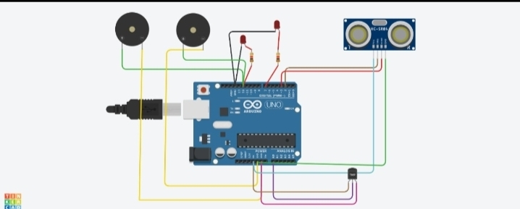

Components Used:

i) 2 Piezo Buzzer

ii)Temperature Sensor

iii)Ultrasonic Sensor

iv) LED -2

v)Resistor-2

**Code:**

int t=2;

int e=3;

void setup()

{

Serial.begin(9600);

pinMode(t,OUTPUT);

pinMode(e,INPUT);

pinMode(12,OUTPUT);

}

void loop()

{

//ultrasonic sensor

digitalWrite(t,LOW);

digitalWrite(t,HIGH);

delayMicroseconds(10);

digitalWrite(t,LOW);

float dur=pulseIn(e,HIGH);

float dis=(dur*0.0343)/2;

Serial.print("Distance is: ");

Serial.println(dis);

//LED ON

if(dis>=100)//(in terms of centimeter)

{

digitalWrite(8,HIGH);

digitalWrite(7,HIGH);

}

//Buzzer For ultrasonic Sensor

if(dis>=100)

{

for(int i=0; i<=30000; i=i+10)

{

tone(12,i);

delay(1000);

noTone(12);

delay(1000);

}

}

//Temperate Sensor

double a= analogRead(A0);

double t=(((a/1024)*5)-0.5)*100;

Serial.print("Temp Value: ");

Serial.println(t);

delay(1000);

//LED ON

if(t>=100)//(in terms of celsius)

{

digitalWrite(8,HIGH);

digitalWrite(7,HIGH);

}

//Buzzer for Temperature Sensor

if(t>=100)

{

for(int i=0; i<=30000; i=i+10)

{

tone(12,i);

delay(1000);

noTone(12);

delay(1000);

}

}

//LED OFF

if(t<100)

{

digitalWrite(8,LOW);

digitalWrite(7,LOW);

}

}

**TINKERCAD**

https://www.tinkercad.com/things/aPiiIrg4gsS-cool-habbi/editel?sharecode=BmchgPL6lpPvJxnWdhu-LzwkdLiXND5fgibNZcKwN7g